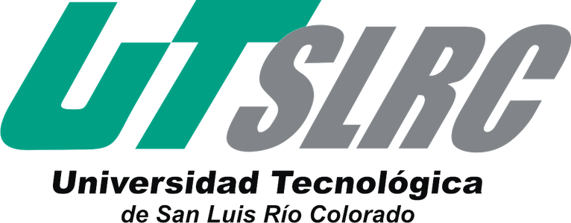

**UNIVERSIDAD TECNOLÓGICA DE**

**SAN LUIS RIO COLORADO**

**Portfolio**

**MTRO. ARNOLDO DELGADO GONZALEZ**

**ALUMNO: VICTOR MANUEL GALVAN COVARRUBIAS**

**Evaluation and improvement for development of software**

**TI 4-3**

San Luis Rio Colorado, Sonora Febrero, 2021

INTRODUCTON

There are many areas that a tech enthusiast can aspire to, and work in these can sometimes be too complicated and demanding.

Working as a tester is a clear example of this. The tester's job goes beyond just making sure everything works. The tester is a fundamental element in the development of any software. He makes it possible for a system or program to be delivered to users correctly.

A tester must have knowledge about all the stages of software development, and also knowledge of the programming languages that will be used for development. A tester ensures that the system meets the requested requirements, inspecting each specific stage of software development. This in turn brings with it advantages in software development, such as reducing costs by finding bugs in the early stages, ensuring the correct launch to market, promoting continuous improvement and maximizing the value of the software.

Throughout this partial, we will begin to become familiar with the basic concepts that a tester constantly handles, in the same way, the procedures and steps that it carries out to fulfill its work within the development team.

Below are the research works carried out during the first partial of the subject “Evaluation and improvement for development of software.”

HW1

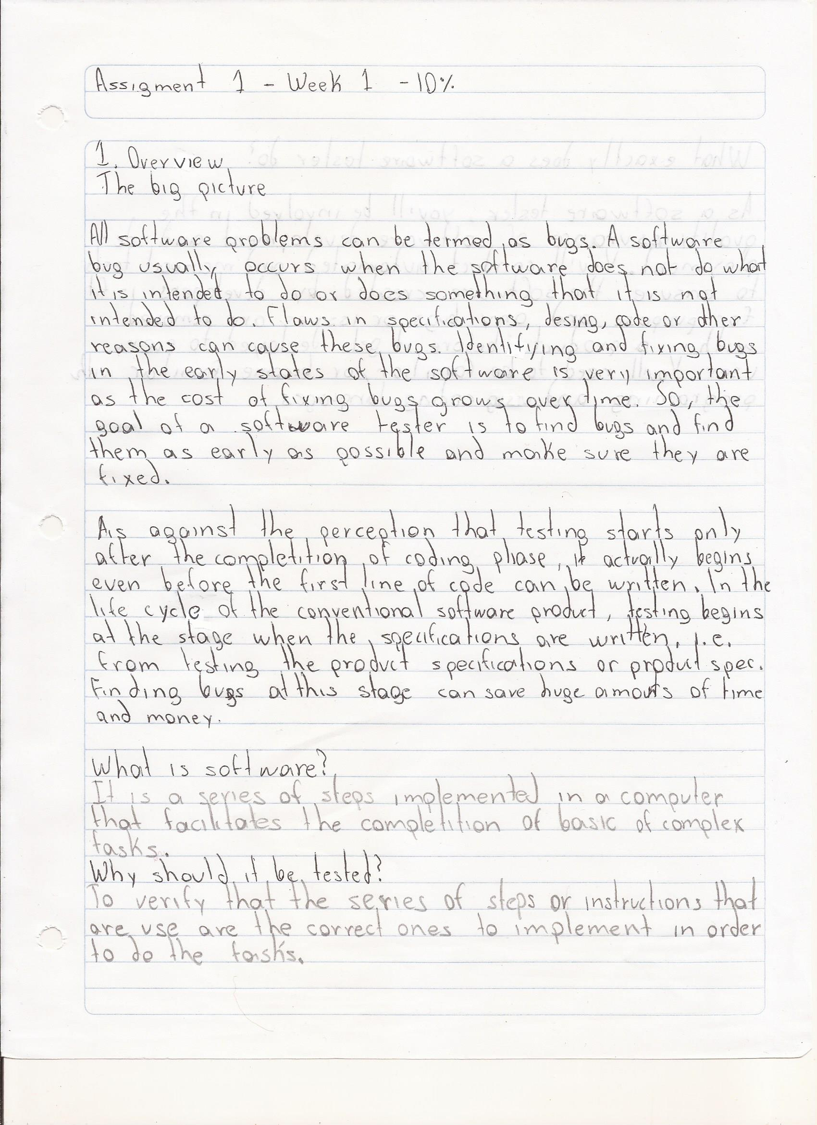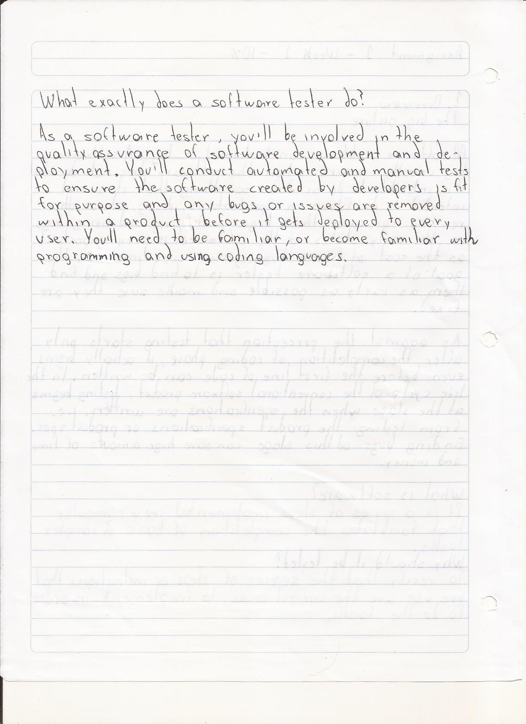

HW2

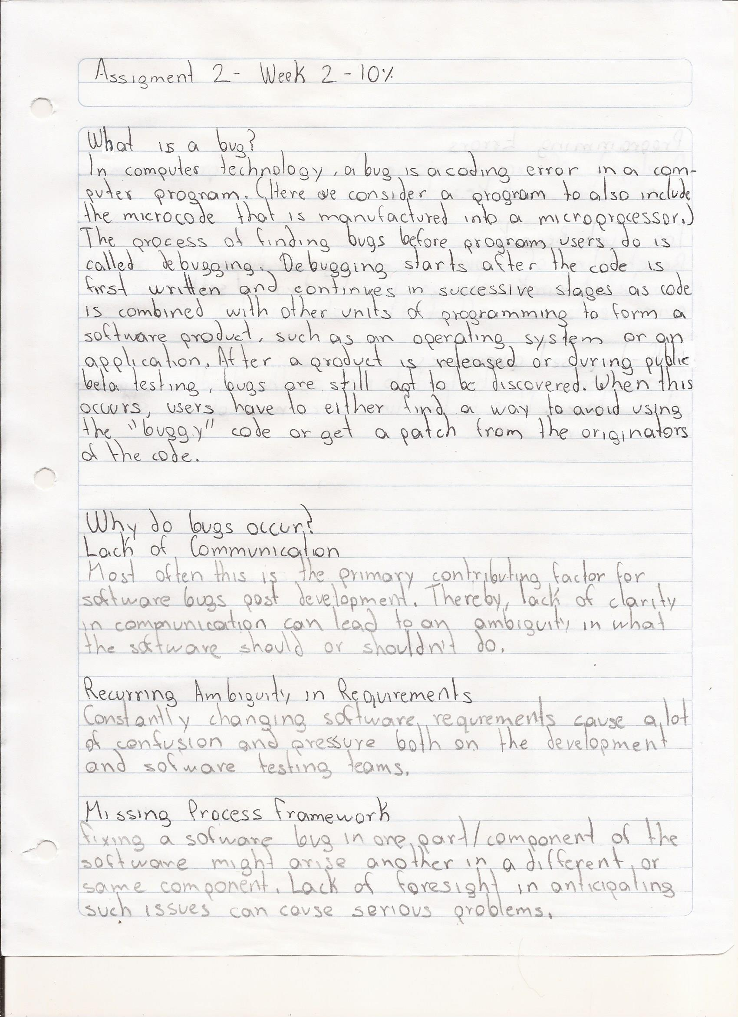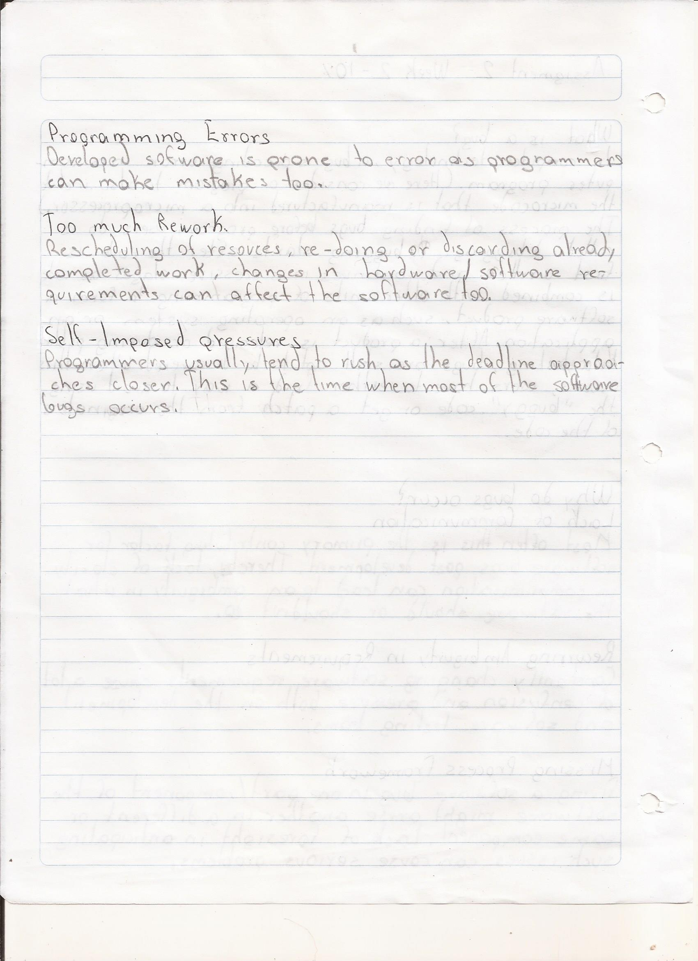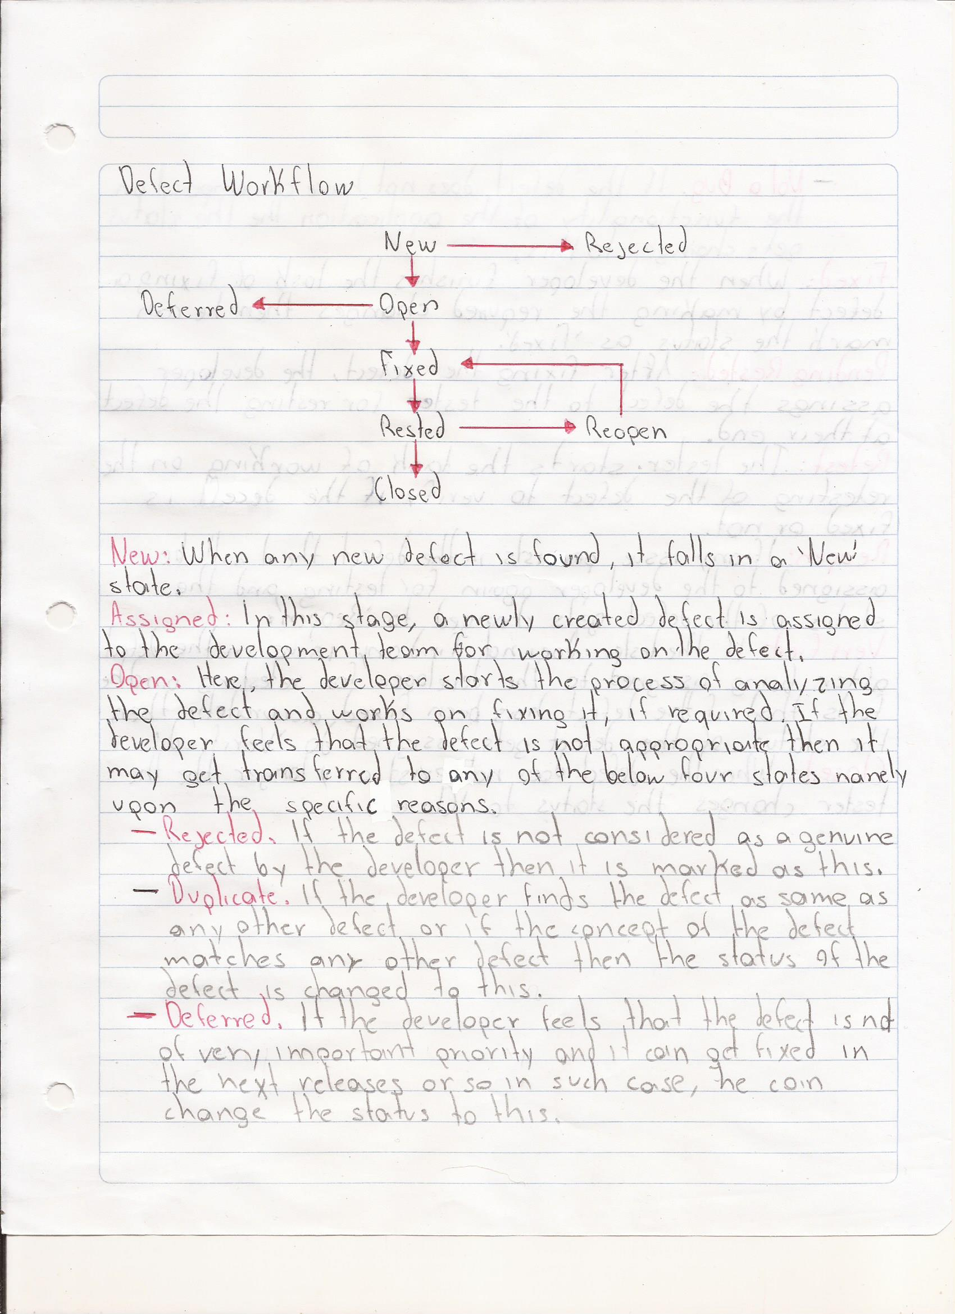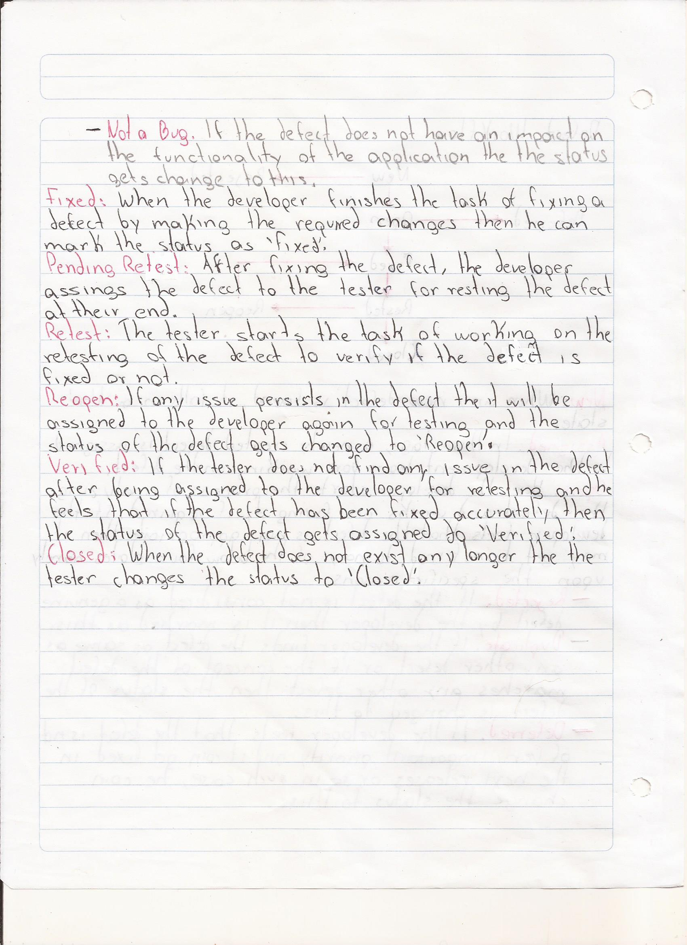

HW3

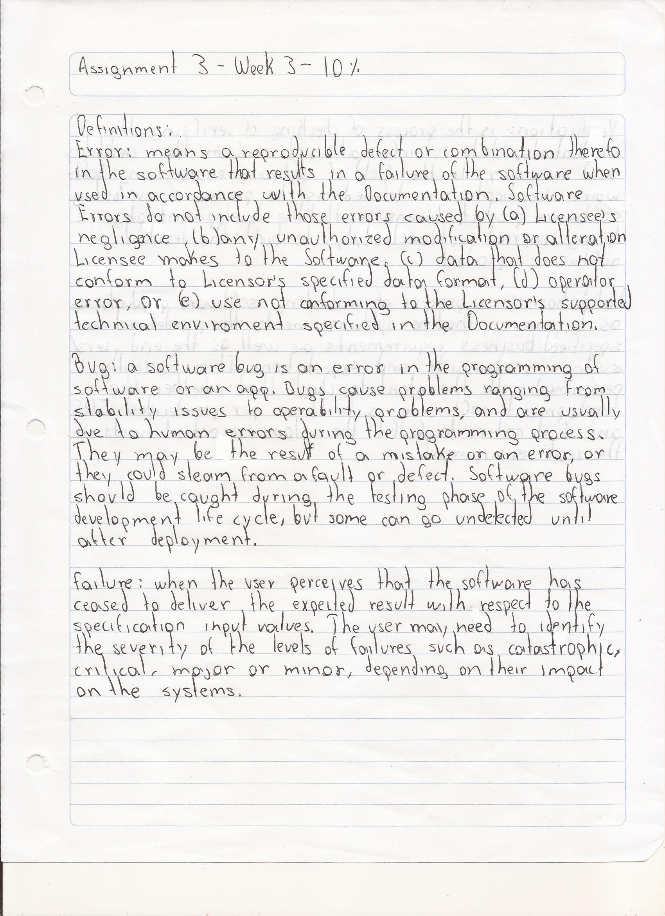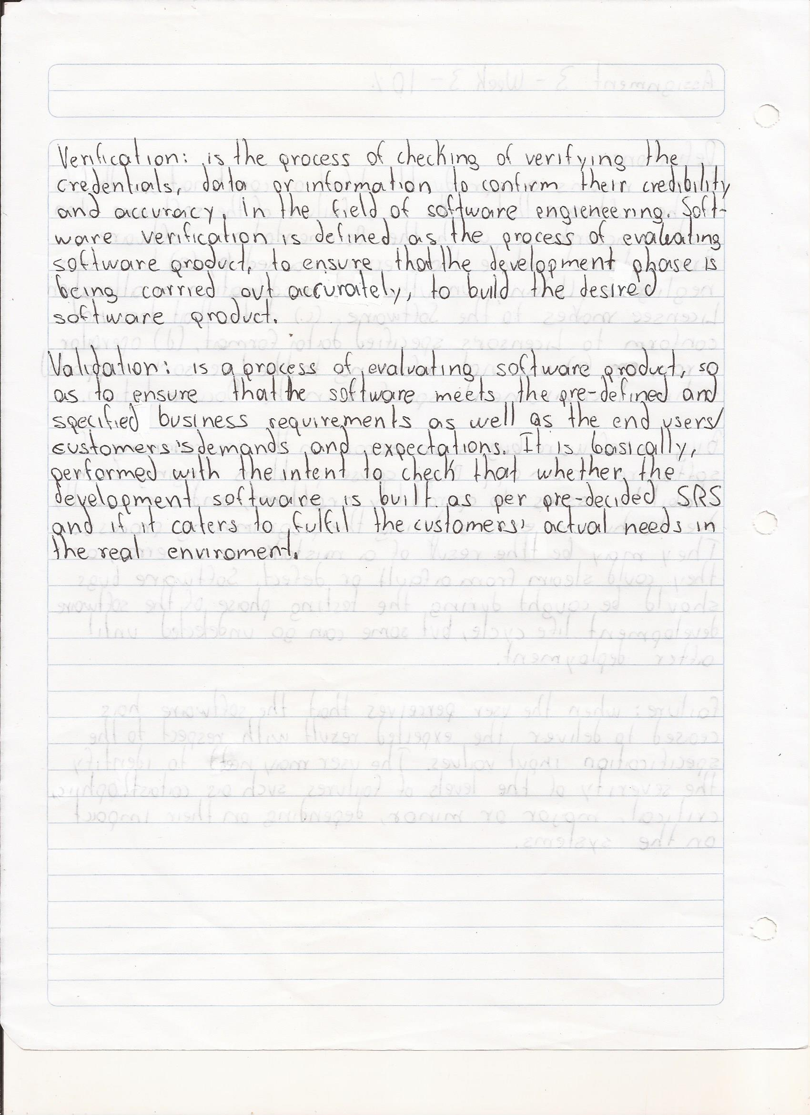

HW4

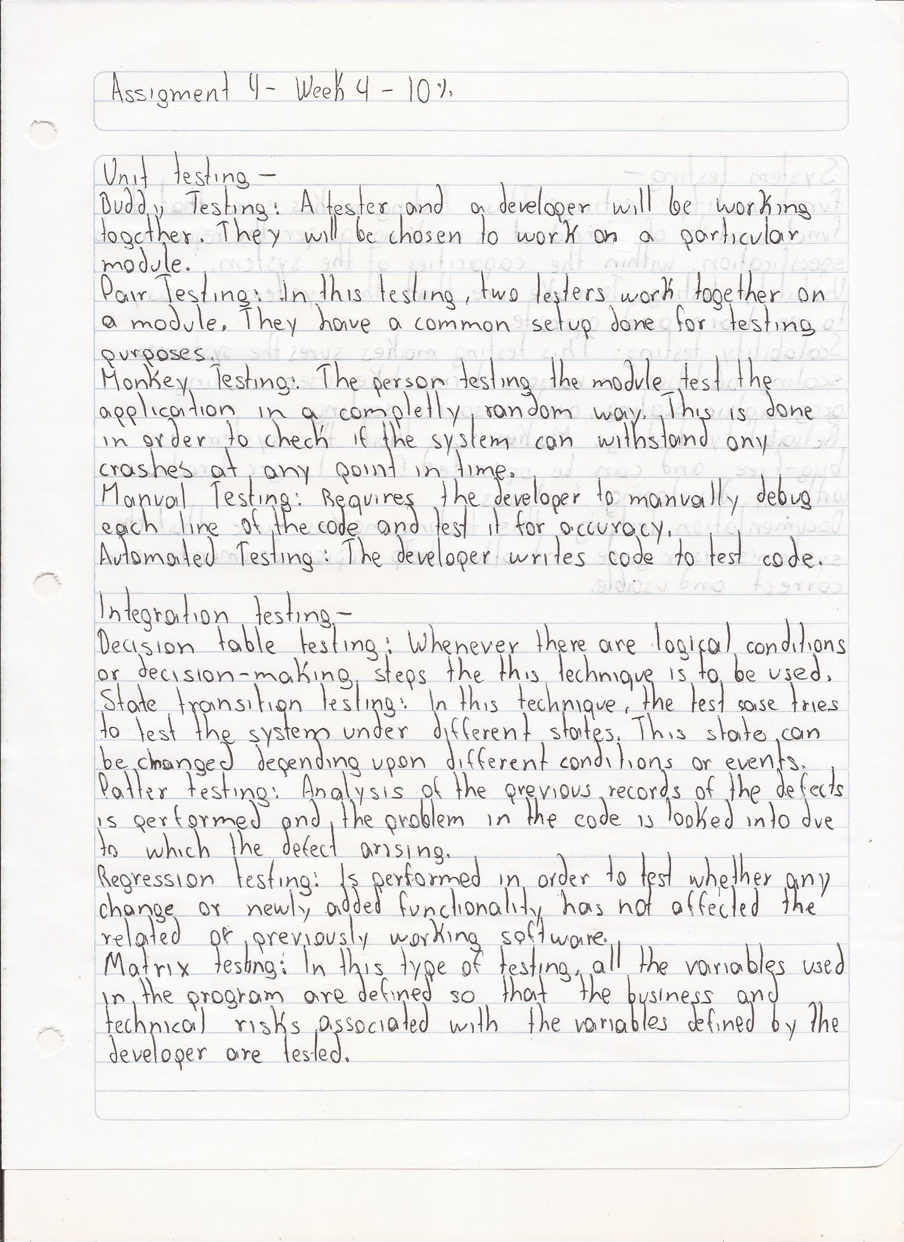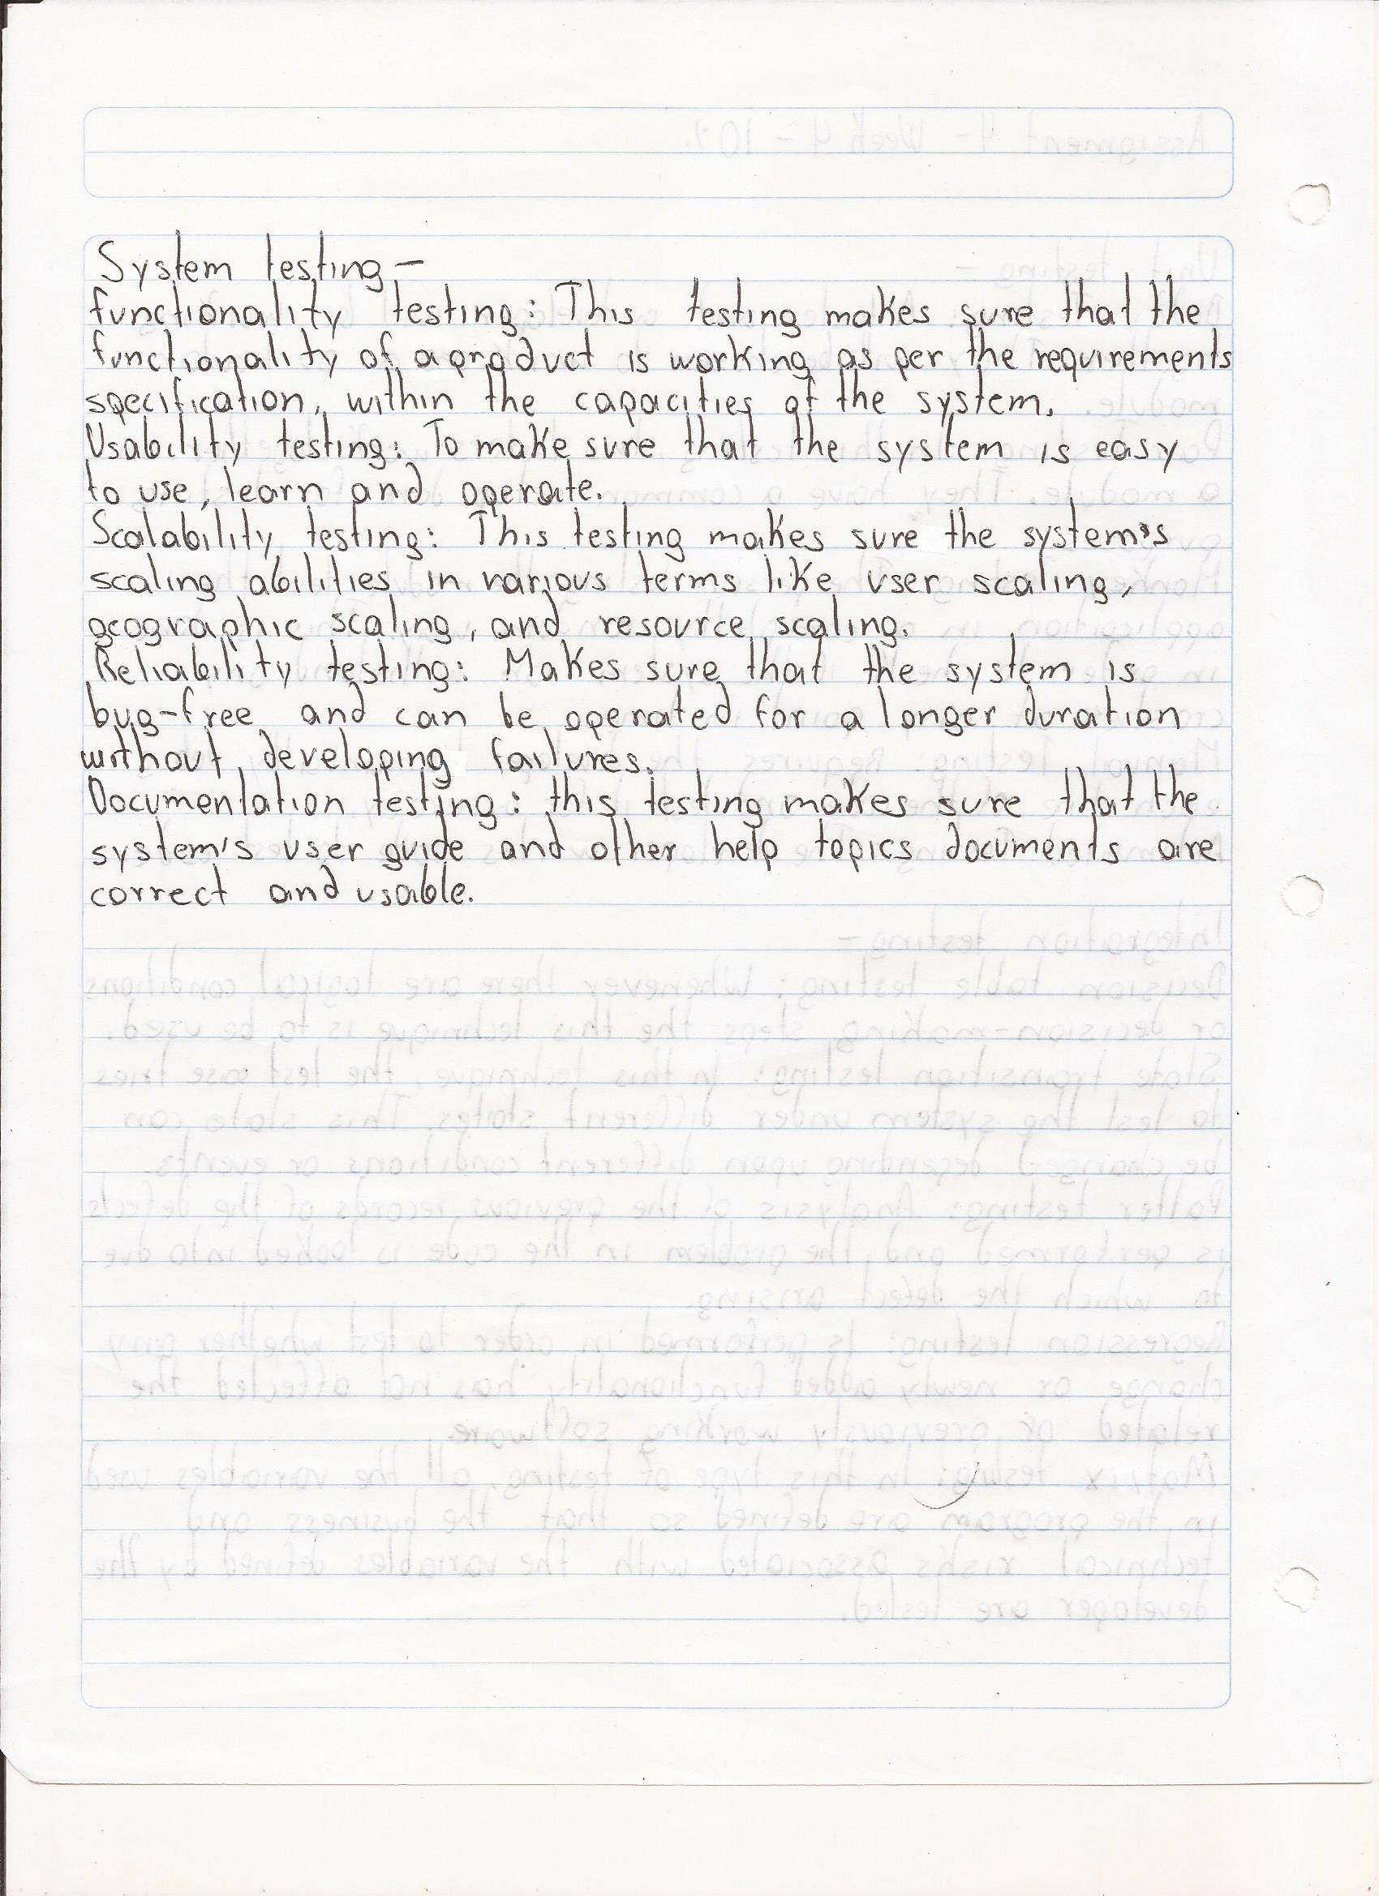

CONCLUTION

Based on the topics seen in partial one, we can easily know if this being a tester interests us or not. Once we have already understood the bases of what a tester does and does not do. We can easily head in the right direction to continue learning and become software testers.

Before continuing to learn it is important to emphasize that the work of a tester is COMPLICATED, you must know everything and once you know about the entire software creation process, you must analyze and inspect everything to make sure that the least amount of bugs is present during its development.

Throughout the partial we have learned basic topics, guide lines for a tester, what is a bug? Bug life cycle, tools for testers, basic terminology, types of errors with examples and also the levels of testing and their types of testing.

Everything learned will be very useful in the following topics to learn within the subject "Evaluation and improvement for software development" and also (if we want to be professional testers) in the near future.